**ELEVATING E-COMMERCE INSIGHTS**

**ADVANCED SQL ANALYSIS OF PRODUCT FUNNEL DYNAMICS**

**BUSINESS OBJECTIVE**

Clique Bait is an online seafood store - the founder and CEO Danny, wants to analyse and come up with creative solutions to calculate Funnel Fallout rates for the Clique Bait online store.

The main objective of this project is to track how many users complete the checkout process, Measuring user activation and retention, and Understanding how users use discount codes.

**DATABASE DESCRIPTION**

The dataset contains 5 tables

| **TABLE_NAME** | **TABLE_ROWS** |
| --- | --- |
| campaign_identifier | 3 |
| event_identifier | 5 |
| events | 32760 |
| page_hierarchy | 13 |
| users | 1782 |

**USERS**

The customers visiting the website are given unique user id and a unique cookie_id for each session.

**EVENTS**

The events table contains entries detailing every page viewed by the customer in each visit ordered by the sequence number column.

**EVENT IDENTIFIER**

The event_identifier table shows the types of events which are captured by Clique Bait’s digital data systems.

**CAMPAIGN IDENTIFIER**

This table contains information about the 3 campaigns that Clique Bait has ran on their website so far.

**PAGE HIERARCHY**

This table contains details of all the pages on the Clique Bait website which are tagged.

**DATA PRE-PROCESSING**

* On initial analysis of data, the datatype of few columns were not appropriate. So the datatypes were modified by using ALTER table commands.

-- ALTER TABLE event_identifier MODIFY event_type integer;

**KEY INSIGHTS**

* There are a total of **500** unique users.
* Each user has an average of 4 cookies which shows good user retention rate.
* The month of **February** had the most number of user visits.

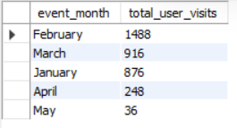

* Around **49.86%** of the site visits ends with a purchase.
* The product category ‘**Luxury’** had the most number of purchases.

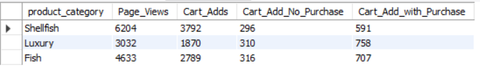

* The product name ‘**oyster’** had the most number of views.
* The highest selling product name was ‘**Lobster’**
* The product ‘**Russian Caviar’** was most likely to be abandoned as it had the highest cart ads without purchase.
* The page view to cart conversion rate was **60.95%**
* The cart to purchase conversion rate was **75.93%**
* Around **85.63%** of visits which ended in purchase happened during AD Campaigns.

**CONCLUSION**

* It is observed that only 9% of users visit the checkout page but do not purchase. This phenomenon signifies a commendably low Funnel Abandonment Rate, delineating the percentage of users who disengage from the conversion process prior to its completion.